**Code:**

**# Python program to demonstrate**

**# basic operations on single array**

**import numpy as np**

**# Defining Array 1**

**a = np.array([[1, 2],[3, 4]])**

**# Defining Array 2cls**

**b = np.array([[4, 3],[2, 1]])**

**# Adding 1 to every element**

**print("Original Array: ",a)**

**print ("Adding 1 to every element:", a + 1)**

**# Subtracting 2 from each element**

**print("\nOriginal Array: ",b)**

**print ("Subtracting 2 from each element:", b - 2)**

**# sum of array elements**

**# Performing Unary operations**

**print("\nGiven Array: ",a)**

**print ("Sum of all array elements: ", a.sum())**

**# Adding two arrays**

**# Performing Binary operations**

**print("\n",a)**

**print("+")**

**print(b)**

**print ("\nArray sum:\n", a + b)**

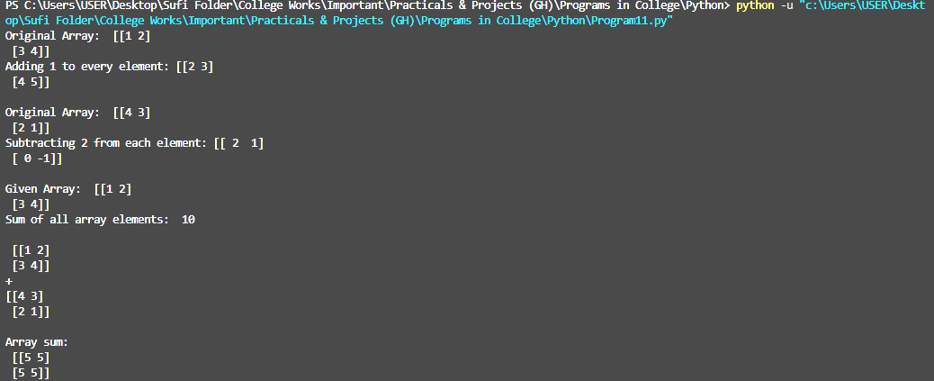**Output:**